MVC (MODEL VIEW CONTOLLER)
MVC and Controller
Assignment 1: Student Result Application
Scenario
Students enter marks and view results.
Requirements
- Create Spring Boot MVC project.
- Create JSP page.
- Create Controller.
- Use Request Mapping.
- Calculate total and average.
Sample Output
Student Result
Total : 450
Average : 90
Solution:
Structure
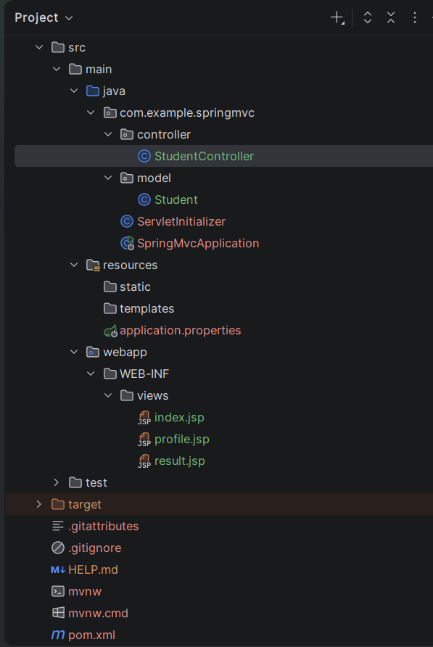

pom.xml
<?xml version="1.0" encoding="UTF-8"?>
<project xmlns="http://maven.apache.org/POM/4.0.0" xmlns:xsi="http://www.w3.org/2001/XMLSchema-instance"
xsi:schemaLocation="http://maven.apache.org/POM/4.0.0 https://maven.apache.org/xsd/maven-4.0.0.xsd">
<modelVersion>4.0.0</modelVersion>
<parent>
<groupId>org.springframework.boot</groupId>
<artifactId>spring-boot-starter-parent</artifactId>
<version>3.3.0</version>
<relativePath/> <!-- lookup parent from repository -->
</parent>
<groupId>com.example</groupId>
<artifactId>SpringMVC</artifactId>
<version>0.0.1-SNAPSHOT</version>
<packaging>war</packaging>
<name>SpringMVC</name>
<description>SpringMVC</description>
<properties>
<java.version>21</java.version>
</properties>
<dependencies>
<dependency>
<groupId>org.springframework.boot</groupId>
<artifactId>spring-boot-starter-web</artifactId>
</dependency>
<dependency>
<groupId>org.apache.tomcat.embed</groupId>
<artifactId>tomcat-embed-jasper</artifactId>
<scope>provided</scope>
</dependency>
<dependency>
<groupId>jakarta.servlet.jsp.jstl</groupId>
<artifactId>jakarta.servlet.jsp.jstl-api</artifactId>
</dependency>
<dependency>
<groupId>org.glassfish.web</groupId>
<artifactId>jakarta.servlet.jsp.jstl</artifactId>
</dependency>
<dependency>
<groupId>org.springframework.boot</groupId>
<artifactId>spring-boot-starter-tomcat</artifactId>
<scope>provided</scope>
</dependency>
<dependency>
<groupId>org.springframework.boot</groupId>
<artifactId>spring-boot-starter-test</artifactId>
<scope>test</scope>
</dependency>
</dependencies>
<build>
<plugins>
<plugin>
<groupId>org.springframework.boot</groupId>
<artifactId>spring-boot-maven-plugin</artifactId>
</plugin>
</plugins>
</build>
</project>

resources/application.properties
spring.application.name=SpringMVC
spring.mvc.view.prefix=/WEB-INF/views/
spring.mvc.view.suffix=.jsp

model/Student.java
package com.example.springmvc.model;
public class Student {
private double mark1;
private double mark2;
private double mark3;
private double mark4;
private double mark5;
public double getMark1() { return mark1; }
public void setMark1(double mark1) { this.mark1 = mark1; }
public double getMark2() { return mark2; }
public void setMark2(double mark2) { this.mark2 = mark2; }
public double getMark3() { return mark3; }
public void setMark3(double mark3) { this.mark3 = mark3; }
public double getMark4() { return mark4; }
public void setMark4(double mark4) { this.mark4 = mark4; }
public double getMark5() { return mark5; }
public void setMark5(double mark5) { this.mark5 = mark5; }
}

controller/StudentController.java
package com.example.springmvc.controller;
import com.example.springmvc.model.Student;
import org.springframework.stereotype.Controller;
import org.springframework.ui.Model;
import org.springframework.web.bind.annotation.GetMapping;
import org.springframework.web.bind.annotation.ModelAttribute;
import org.springframework.web.bind.annotation.PostMapping;
import org.springframework.web.bind.annotation.RequestMapping;
import org.springframework.web.servlet.ModelAndView;
@Controller
@RequestMapping("/student")
public class StudentController {
@GetMapping("/form")
public String showForm(Model model) {
model.addAttribute("student", new Student());
return "index";
}
@PostMapping("/calc")
public String calculateResult(@ModelAttribute("student") Student student, Model model) {
double total = student.getMark1() + student.getMark2() +
student.getMark3() + student.getMark4() +
student.getMark5();
double average = total / 5.0;
model.addAttribute("total", (int) total);
model.addAttribute("average", (int) average);
return "result";
}
@GetMapping("/profile")
public ModelAndView getStudentProfile() {
ModelAndView mav = new ModelAndView();
mav.addObject("name", "Vishnu");
mav.addObject("course", "Java Full Stack");
mav.setViewName("profile");
return mav;
}
}

ServletInitializer.java
package com.example.springmvc;
import org.springframework.boot.builder.SpringApplicationBuilder;
import org.springframework.boot.web.servlet.support.SpringBootServletInitializer;
public class ServletInitializer extends SpringBootServletInitializer {
@Override
protected SpringApplicationBuilder configure(SpringApplicationBuilder application) {
return application.sources(SpringMvcApplication.class);
}
}

SpringMvcApplication.java
package com.example.springmvc;
import org.springframework.boot.SpringApplication;
import org.springframework.boot.autoconfigure.SpringBootApplication;
@SpringBootApplication
public class SpringMvcApplication {
public static void main(String[] args) {
SpringApplication.run(SpringMvcApplication.class, args);
}
}

views/index.jsp
<%@ page language="java" contentType="text/html; charset=UTF-8" pageEncoding="UTF-8"%>
<!DOCTYPE html>
<html>
<head>
<title>Student Marks Entry</title>
</head>
<body>
<h2>Enter Marks</h2>
<form action="${pageContext.request.contextPath}/student/calc" method="post">
Mark 1: <input type="number" name="mark1" required /><br/><br/>
Mark 2: <input type="number" name="mark2" required /><br/><br/>
Mark 3: <input type="number" name="mark3" required /><br/><br/>
Mark 4: <input type="number" name="mark4" required /><br/><br/>
Mark 5: <input type="number" name="mark5" required /><br/><br/>
<input type="submit" value="Calculate Result" />
</form>
</body>
</html>

views/result.jsp
<%@ page language="java" contentType="text/html; charset=UTF-8" pageEncoding="UTF-8"%>
<!DOCTYPE html>
<html>
<head>
<title>Student Result</title>
</head>
<body>
<h2>Student Result</h2>
<p>Total : ${total}</p>
<p>Average : ${average}</p>
</body>
</html>

views/Profile.jsp
<%@ page language="java" contentType="text/html; charset=UTF-8" pageEncoding="UTF-8"%>
<!DOCTYPE html>
<html>
<head>
<title>Student Profile</title>
</head>
<body>
<h2>Student Details</h2>
<p><strong>Name : </strong>${name}</p>
<p><strong>Course : </strong>${course}</p>
</body>
</html>

Output:
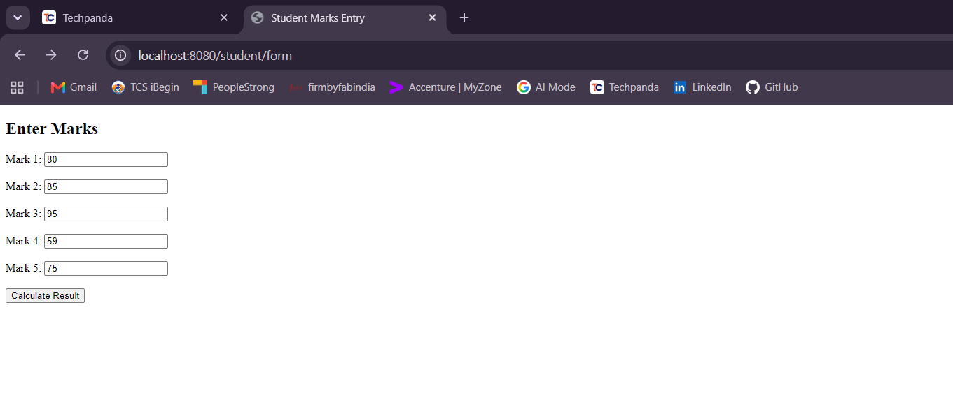
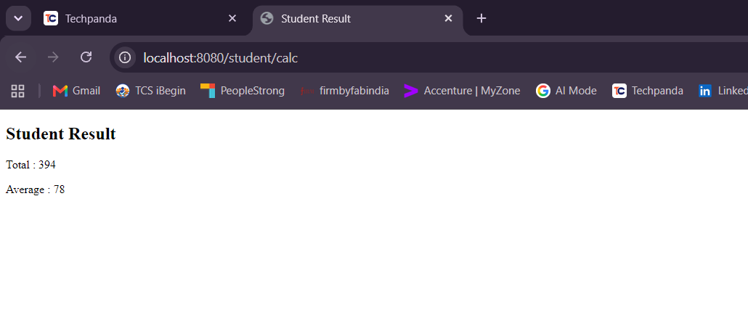

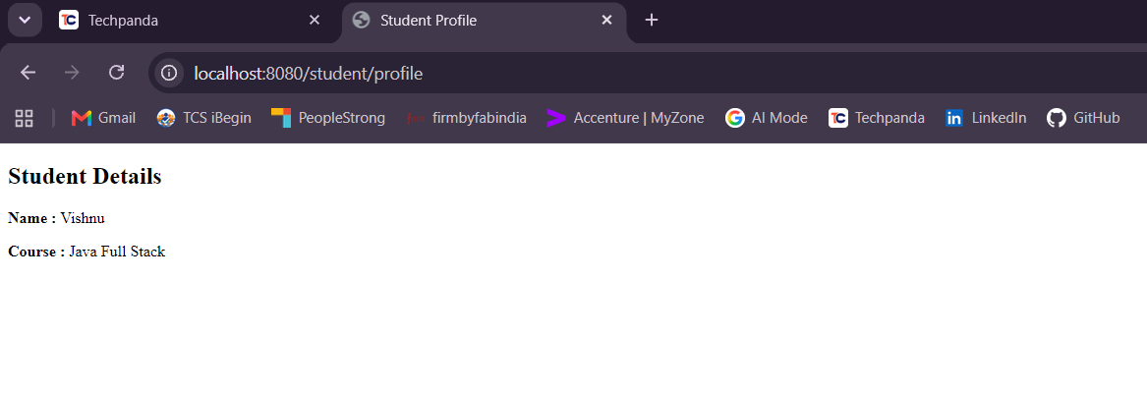
Exploring Web MVC without Spring Boot

Assignment 1: Student Information Portal
Scenario
Develop a Spring MVC application without Spring Boot.
Requirements
- Configure Dispatcher Servlet.
- Configure View Resolver.
- Display student details.
Sample Output
Student Information
Name : Arun
Age : 20

Solution:
Structure

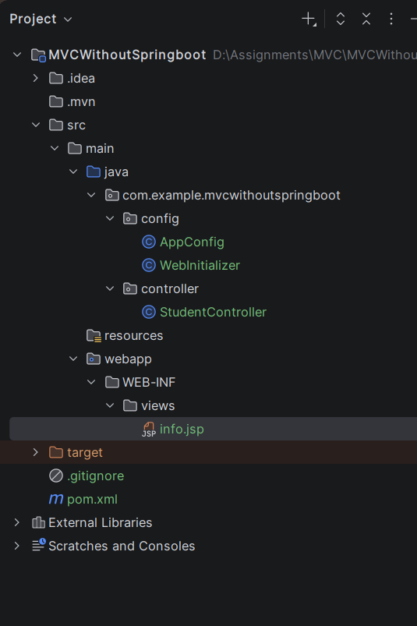
pom.xml
<project xmlns="http://maven.apache.org/POM/4.0.0" xmlns:xsi="http://www.w3.org/2001/XMLSchema-instance"
xsi:schemaLocation="http://maven.apache.org/POM/4.0.0 http://maven.apache.org/maven-v4_0_0.xsd">
<modelVersion>4.0.0</modelVersion>
<groupId>com.example</groupId>
<artifactId>MVCWithoutSpringboot</artifactId>
<packaging>war</packaging>
<version>1.0-SNAPSHOT</version>
<name>MVCWithoutSpringboot Maven Webapp</name>
<url>http://maven.apache.org</url>
<dependencies>
<dependency>
<groupId>junit</groupId>
<artifactId>junit</artifactId>
<version>3.8.1</version>
<scope>test</scope>
</dependency>
<!-- Source: https://mvnrepository.com/artifact/org.springframework/spring-webmvc -->
<dependency>
<groupId>org.springframework</groupId>
<artifactId>spring-webmvc</artifactId>
<version>7.0.8</version>
<scope>compile</scope>
</dependency>
<!-- Source: https://mvnrepository.com/artifact/jakarta.servlet/jakarta.servlet-api -->
<dependency>
<groupId>jakarta.servlet</groupId>
<artifactId>jakarta.servlet-api</artifactId>
<version>6.1.0</version>
<scope>provided</scope>
</dependency>
<!-- Source: https://mvnrepository.com/artifact/jakarta.servlet.jsp/jakarta.servlet.jsp-api -->
<dependency>
<groupId>jakarta.servlet.jsp</groupId>
<artifactId>jakarta.servlet.jsp-api</artifactId>
<version>4.0.0</version>
<scope>compile</scope>
</dependency>
</dependencies>
<build>
<finalName>MVCWithoutSpringboot</finalName>
</build>
</project>

config/AppConfig.java
package com.example.mvcwithoutspringboot.config;
import org.springframework.context.annotation.Bean;
import org.springframework.context.annotation.ComponentScan;
import org.springframework.context.annotation.Configuration;
import org.springframework.web.servlet.ViewResolver;
import org.springframework.web.servlet.config.annotation.EnableWebMvc;
import org.springframework.web.servlet.config.annotation.WebMvcConfigurer;
import org.springframework.web.servlet.view.InternalResourceViewResolver;
@Configuration
@EnableWebMvc
@ComponentScan(basePackages = "com.example.mvcwithoutspringboot")
public class AppConfig implements WebMvcConfigurer {
@Bean
public ViewResolver internalResourceViewResolver() {
InternalResourceViewResolver resolver = new InternalResourceViewResolver();
resolver.setPrefix("/WEB-INF/views/");
resolver.setSuffix(".jsp");
return resolver;
}
}

config/WebInitializer.java
package com.example.mvcwithoutspringboot.config;
import org.springframework.web.WebApplicationInitializer;
import org.springframework.web.context.support.AnnotationConfigWebApplicationContext;
import org.springframework.web.servlet.DispatcherServlet;
import jakarta.servlet.ServletContext;
import jakarta.servlet.ServletException;
import jakarta.servlet.ServletRegistration;
public class WebInitializer implements WebApplicationInitializer {
@Override
public void onStartup(ServletContext servletContext) throws ServletException {
AnnotationConfigWebApplicationContext context = new AnnotationConfigWebApplicationContext();
context.register(AppConfig.class);
ServletRegistration.Dynamic dispatcher = servletContext.addServlet("dispatcher", new DispatcherServlet(context));
dispatcher.setLoadOnStartup(1);
dispatcher.addMapping("/");
}
}

controller/StudentController.java
package com.example.mvcwithoutspringboot.controller;
import org.springframework.stereotype.Controller;
import org.springframework.ui.Model;
import org.springframework.web.bind.annotation.GetMapping;
import org.springframework.web.bind.annotation.RequestMapping;
@Controller
@RequestMapping("/student")
public class StudentController {
@GetMapping("/info")
public String getStudentInfo(Model model) {
model.addAttribute("name", "Vishnu");
model.addAttribute("age", 20);
return "info";
}
}

views/info.jsp
<%@ page language="java" contentType="text/html; charset=UTF-8" pageEncoding="UTF-8"%>
<!DOCTYPE html>
<html>
<head>
<title>Student Information</title>
</head>
<body>
<h2>Student Information</h2>
<p>Name : ${name}</p>
<p>Age : ${age}</p>
</body>
</html>

Tomcat server configuration in Intelij
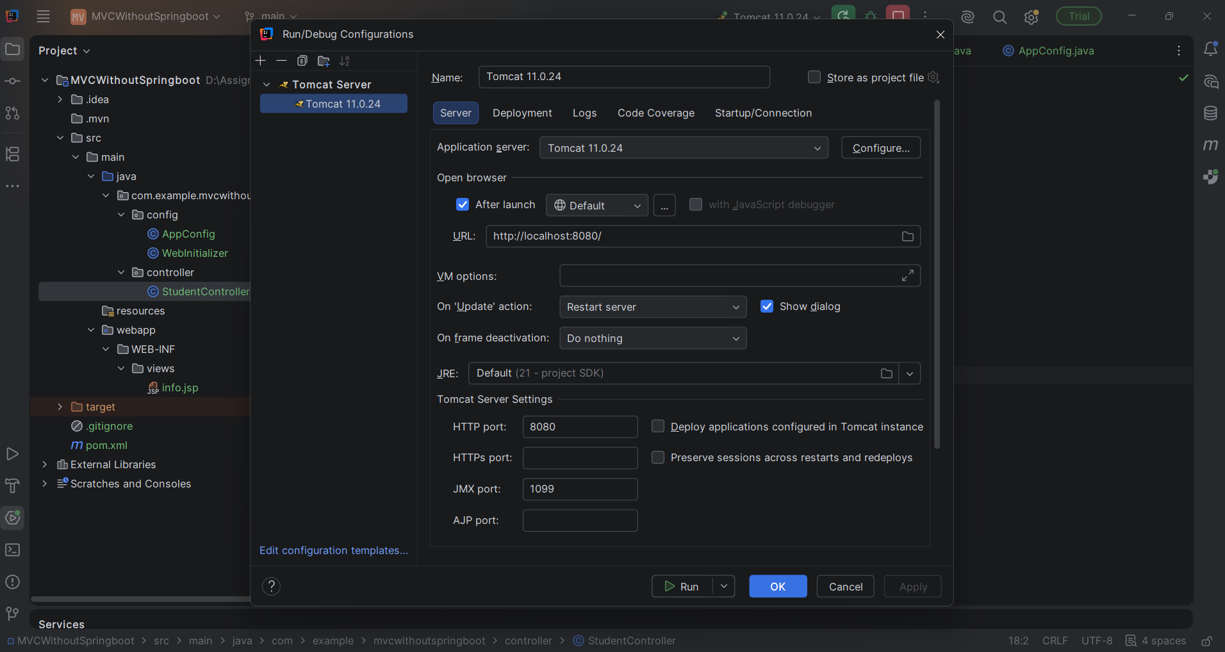

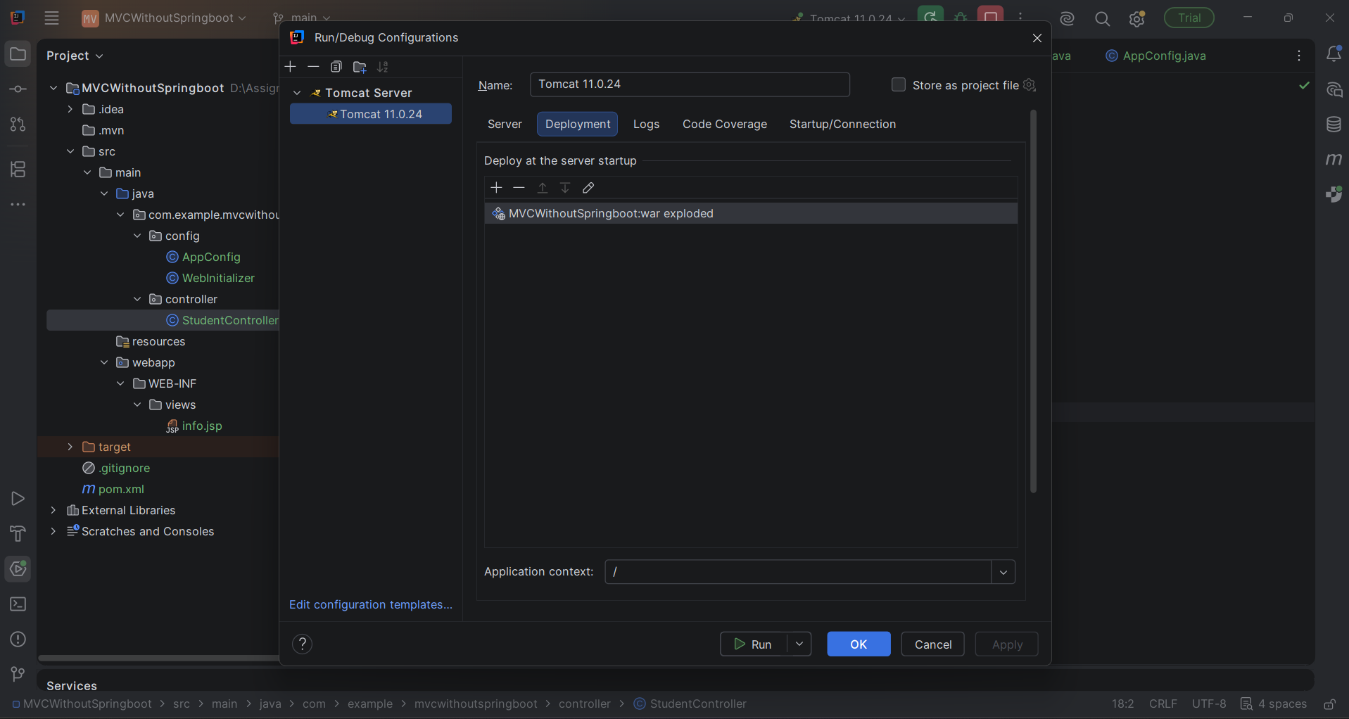

Output:
